Assessment Schedule – 2011
Mathematics and Statistics: Investigate relationships between tables, equations and graphs (91028)
Evidence Statement
Question | Expected Coverage | Achievement (u) | Achievement with Merit (r) | Achievement with Excellence (t)
 |  | Investigate relationships between tables, equations and graphs. | Investigate relationships between tables, equations and graphs, using relational thinking. | Investigate relationships between tables, equations and graphs, using extended abstract thinking.
ONE  (a)(i) | Graph drawn from table.  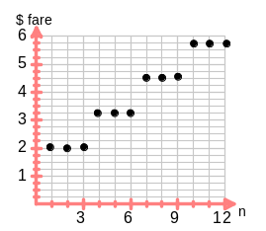 | Table is linked to graph for stages and costs, (rather than stations and costs) as a straight line, $ = 3n, but this simplifies the situation for Q1aii.  Accept sloping lines connecting the “steps”. | Graph drawn as horizontal sets of points for stages according to multiples of three.  Accept ambiguity at boundaries between fares, eg when bars “touch”. | Graph is drawn as discrete step function.  Accept continuous steps and accept bars, so long as the fares are correct for each number of stations and none are ambiguous.
(ii) | Child’s fare increases smaller.  Child’s fare starts at a lower value.  Increase for children’s fares 3/5 of adult.  Both have constant increases. | ONE aspect described.  Accept consistency with the graph drawn. | TWO valid comparisons.  If the comparison has been simplified by 1ai graph, maximum grade here is “u”
(b)(i)  (ii) | $40  Rule given:  S = 40n – 200 | Correct value.  Correct gradient or intercept.  Accept EITHER response as evidence for “u”. | Correct equation given.  Consistent use of incorrect gradient in (ii) is still an error, as no grade has yet been” lost” by it in part (i).
(b)  (iii) | - 4 – 9 weeks, S = 68n – 312  OR The graph is steeper than before because he now saves $68 per week  - At 9 weeks, vertical jump, because of the $50 received from Grandma.  - > 9 weeks, S = 68n – 262  OR graph is parallel to the last one because he is still saving $68 per week. | Graph drawn correctly – a straight line (or line of discrete points):  (4,–40) to (9,300).  OR  ONE qualitative comment relating to changes in the graph. | Partial description given including at least ONE quantitative comment.  OR  ONE equation. | Full description given including at least TWO quantitative comments.  OR  BOTH equations.

NØ – no response, no relevant evidence
N1 – at least one attempt at one part-question
N2 – one of u
A3 – 2 of u OR t AND u OR r AND u
A4 – 3 of u
M5 – 1 of r AND 2 of u OR t AND 2 of u
M6 – 2 of r OR 1 of r AND 3 of u OR t AND 3 of u
E7 – 1 of t AND 1 of r
E8 – 2 of t OR 1 of t AND 2 of r

Question | Expected Coverage | Achievement | Achievement with Merit | Achievement with Excellence
 |  | Investigate relationships between tables, equations and graphs. | Investigate relationships between tables, equations and graphs, using relational thinking. | Investigate relationships between tables, equations and graphs, using extended abstract thinking.
TWO  (a) | Graph drawn from table.  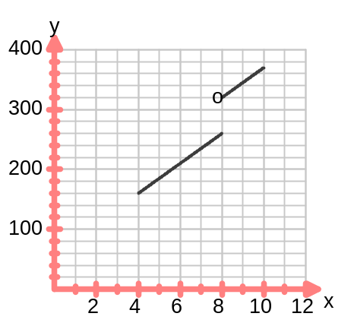 | Sketch plots points correctly for 4 – 8 hours.  Accept discrete plot.  Accept the two continuous plots for:4-8 hours and  9-12hours, connected by a 3rd line.  Accept a bar graph. | Plots both parts correctly and continuously:  4 – 8 hours and  8 – 12hours, ie accept ambiguity at 8.  Accept discrete points plotted. | Deals with the step up correctly i.e. cost for 8hrs is $260 and not $320  TWO continuous pieces, with no ambiguity.  Accept absence of points between 8 and 9 hours.
(b)  (c) | $60  At the end of 8 hours, another $60 payment of travel is required. | Value found.  Description given.  Accept either as evidence for “u”.
(d) | labour = 30 × 25 = 750  Travel = 4 × 60 = 240  Total = 990 | Correctly finds: Cost of labour.  OR  Cost of travel. | Correct cost found.  Consistent with parts (b) and (c) above.
(e) | Zarko: P = 35h  Ian: P = 25h + 60d  (for day number d.)  For day 1, 0 – 8hrs:  35n = 25h + 60  n = 6  For day 2, 8 – 16hrs:  35n = 25n + 120  n = 12  For day 3, 16 – 24hrs:  35h = 25h + 180  h = 18  For day 4, 24 – 32 hrs:  35h = 25h+ 240  h = 24, which is NOT a number of hours for day 4! There will be no further intersections of Ian and Zarko’s graphs. | Finds one correct solution.  OR  Misinterpretation of the question (which simplifies the problem) results in finding Zarko’s hours that give the same final cost as Q2(d). Ie, look for 2(d) answer, being divided by 35. | Equation formed and used OR graph used to find to find one solution.  Accept the use of a table to justify the solution. | Finds two correct solutions, with support: graph and/or equation. No incorrect values given.  Accept the use of a table to justify the solution.
(f) | P = 40h + 60 | Correct gradient OR intercept in the equation. | Equation given.
NØ – no response, no relevant evidence
N1 – at least one attempt at one part-question
N2 – one of u
A3 – 2 of u OR t and u OR r and u
A4 – 3 of u
M5 – 1 of r AND 2 of u OR t AND 2 of u
M6 – 2 of r OR 1 of r AND 3 of u OR t and 3 of u
E7 – 1 of t AND 1 of r
E8 – 2 of t OR 1 of t AND 2 of r

Question | Expected Coverage | Achievement | Achievement with Merit | Achievement with Excellence
 |  | Investigate relationships between tables, equations and graphs. | Investigate relationships between tables, equations and graphs, using relational thinking. | Investigate relationships between tables, equations and graphs, using extended abstract thinking.
THREE  (a) | Each time a table is added, 4 more people are added to the total, 2 on each side of the table.  With ONE of:  - 4 is the number in front of n in the equation  - and 4 is the slope of the graph  There are 2 people, one at each end, of every table arrangement.  With ONE of:  - 2 is the number added to the 4n in the equation  - 2 is where the graph would cut the y axis(although not really meaningful here).  Graph has been drawn as discrete points as you cannot have part people or tables OR a comment that n and p are whole numbers. | ONE valid comment relating the graph or the equation to the number of people at the tables. | TWO valid comments relating the graph or the equation to the number of people at the tables. | THREE valid comments relating the graph or the equation to the number of people at the tables.
(b) | 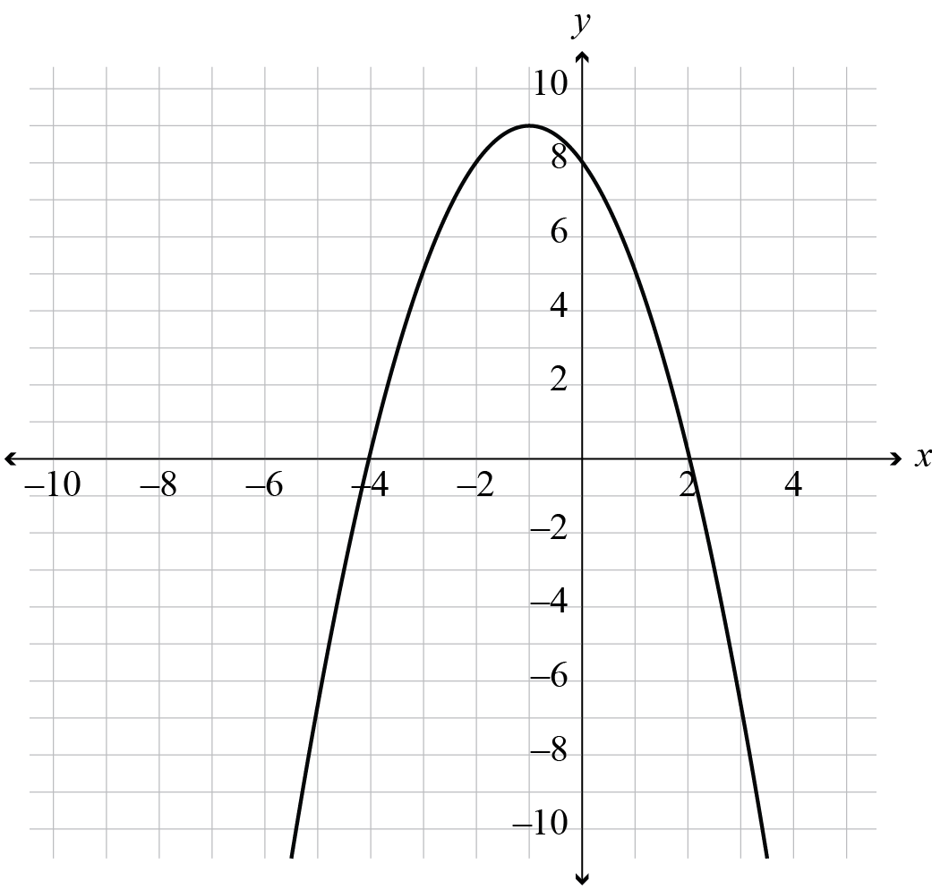 | Correct graph  x-intercepts, –4 and 2,  y-intercept, 8  orientation,  maximum (–1,9)
(c)(i)  (ii)  (iii) | x-intercepts (3,0)  and (–3,0)  Accept x = –3, 3  y-intercept (0,–9)  Accept y = –9  Equation  y = (x +3)(x – 3)  OR y = x² – 9  y = (x + 2)(x – 4) + 2  OR y = (x – 1)² – 7 or  y = x² – 2x – 6  Intercept (0,–6) | Giving the intercepts.  y-intercept (0,–6)  Accept either response as evidence for “u”. | Giving a complete equation.  Either change in brackets, or constant correct, or equivalent.  Accept either response as evidence for “r”. | Equation correctly given.
(d)(i)  (ii) | 2 = –ax(x – 6)  Mid-flight x = 3  2 = –3a × –3  a =  (axes placed at LH end)  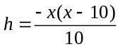  OR h = –0.1x² + x  OR h = –0.1(x – 5)² + 2.5  (centrally placed axes)  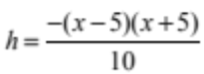  OR h = –0.1(x – 5)²  OR h = –0.1x² + 2.5  (axes placed at RH end)  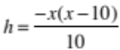  OR h = –0.1x² – x  OR  h = –0.1(x + 5)² + 2.5 | Use of 3 as the mid-point of the flight.  An equation given involving:  x(x – 10)  OR (x + 5)(x – 5)  OR (x – 5)²  Accept either response as evidence for “u”. | Correct value of a found.  Any rounding of decimal equivalent is acceptable.  Equation with one error in:  - orientation  - or with a factor of 10  instead of 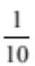  Accept either response as evidence for “r”. | Correct equation.  (any form)  Accept the misinterpretation that uses a maximum height of 4.5 m (ie 2 m + 2.5 m). The problem is still of the required level of difficulty.  The coefficient of x² will be  –0.18 or 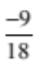 instead of  –0.1.
NØ – no response, no relevant evidence
N1 – at least one attempt at one part-question
N2 – one of u OR one of r OR one of t
A3 – 2 of u OR r AND u OR t AND u
A4 – 3 of u
M5 – 1 of r AND 2 of u OR t AND 2 of u
M6 – 2 of r OR 1 of r AND 3 of u OR t AND 3 of u
E7 – 1 of t AND 1 of r
E8 – 2 of t OR1 of t AND 2 of r

Judgement Statement
 | Not Achieved | Achievement | Achievement  with Merit | Achievement  with Excellence
Score range | 0 – 8 | 9 – 14 | 15 – 18 | 19 – 24

